**Key Features**

Type-C

Form Factor

USB 3.2

Interface

400MB/s Seq. reads

512GB

Capacity

• Fast read speeds with a USB 3.2 interface gives you more time to work, play, watch and create.  
  
• Whether you’re using a PC or a mobile device,\* count on the USB Type-C for compatibility.  
  
• Save Ultra High Resolution videos directly onto the USB Type-C with your favorite camera or mobile devices.  
  
• The ultra-sleek USB-C drive looks as good as it performs. Featuring a reversible plug, the Type-C™ inserts into your devices seamlessly every time.  
  
• The Samsung USB Type-C is tough enough to take on everything with protection from elements like water to extreme temperatures.

Storage

**64GB**

$13.99

**128GB**

$17.99- Current Price$20.99- original price

**Save $3.00**

**256GB**

$26.99- Current Price$34.99- original price

**Save $8.00**

**512GB**

$54.99- Current Price$64.99- original price

**Save $10.00**

Color

Blue

Get it by Dec. 23

Get it by Dec. 23

**VIP Advantage**

**VIP Advantage membershipLearn more**

* 2 Year Samsung Care+ (without Theft and Loss)
* Exclusive Discounts & Early Access

To select this option, please sign in or create a Samsung account

**Premium Benefits**

**$149.99/yr**

**Delivery & professional services**

Availability for:

10001

Delivery

**Delivery**

Not available

**Choose your purchase option**

Questions? Ask a Financing Expert

**One-time Payment**

**$54.99**

**Pay in 4 Installments**

**$13.75**

**every two weeks σπ**

**One-time payment**

Pay with your credit card, debit card or a pay app. Excludes taxes and shipping.

**USB Type-C™ Flash Drive 512GB Blue$54.99**

**Total**

**$54.99 $64.99- original price**

**You Saved Today$10.00**



**Log in now to earn up to 1.5% back in Samsung Rewards Points**

**Add to cart**

[**Where to buy**](https://www.samsung.com/us/computing/memory-storage/usb-flash-drives/usb-type-c-flash-drive-512gb-blue-muf-512da-am-buy)

Supported payment types:

adyen_cardsPayPal Venmo Checkoutamazonpaygooglepay

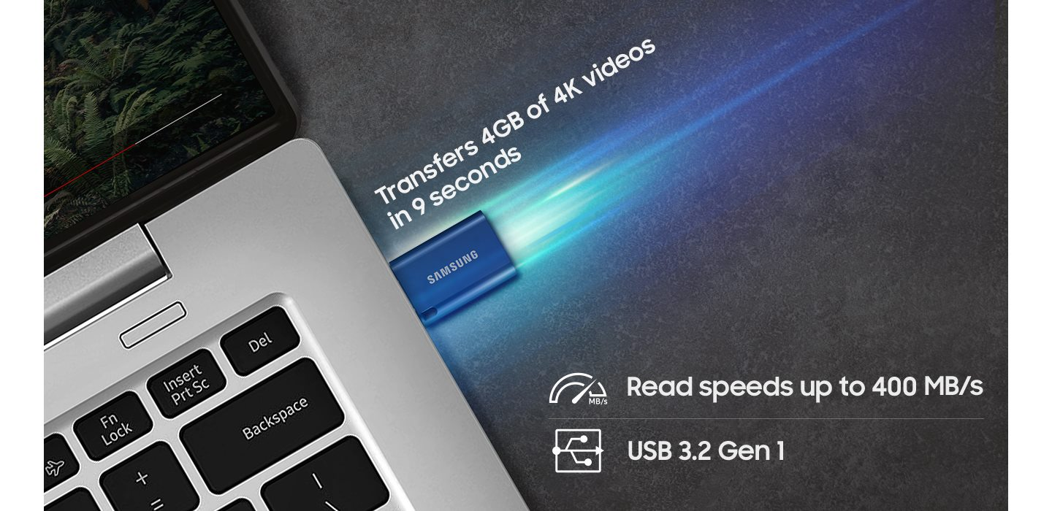

**Move files in a flash**

Get your time back. Fast and convenient read speeds up to 400MB/s¹ with a USB 3.2 interface gives you more time to work, play, watch and create.